Introduction
CV: this part is assigned to Rong jia, but he seems to be busy and has not attend our ingroup discussion for a long time.
Methods
- 3D reconstruction
To do 3D reconstruction, a pile of photos from different angles would be taken to input to the softer ware called , it can produce the 3d model automatically once the feature points on each photo are recognized and aligned successfully.
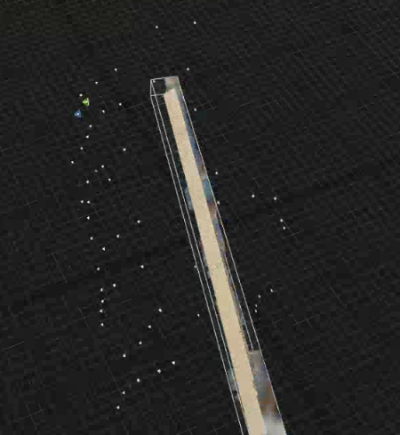
- Alignment/transform
2.2.1
To locate the total eight ends of the beam, the class called ‘find_end’ is created. After inputting the original model, eg. stl files, the simplified possible ends in 3D plot should easily appear and in this way the eight ends can be manually found out in a relatively easy and simple way.
The convex hull detection in the ‘open 3d’ package is used to simplify millions of cloud points into one hundred or so points. The principal is by making tetrahedron made by four points. For the end in the tetrahedron, it would be omitted. For the point outside the tetrahedron, create a new tetrahedron, omitting one origin possible end. In the end, the convex hull detection can find out all possible ends, which contain the real eight ends. Then, ‘plotly’ package is used to show these points with coordinates. As a result, the eight vertexes can be recognized manually, which is important for later similarity transformation.
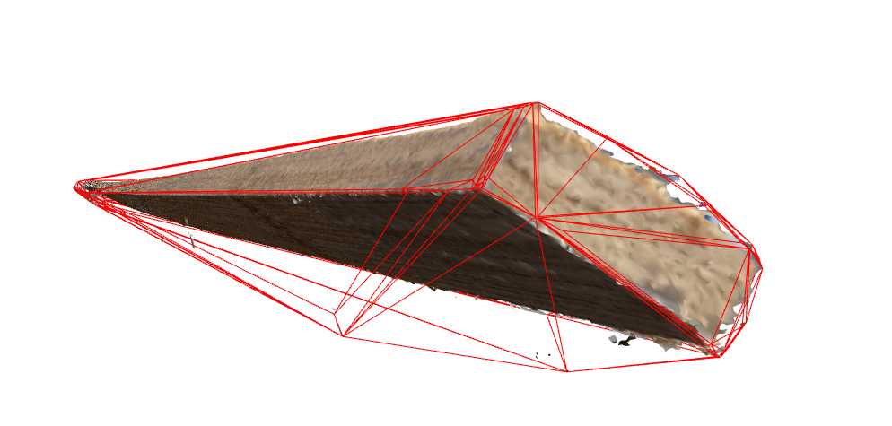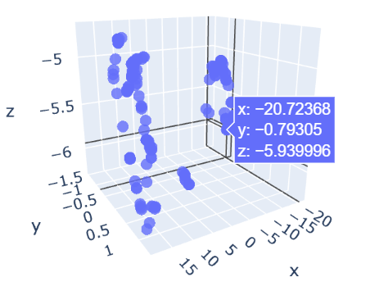
Figure 1: convex hull detection Figure 2: simplified cloud points

2.2.2
The main goal of this part is to align the eight vertexes of the cuboid from the FEM model and those from computer vision model with the transformation matrixes. The key is to find the rotation matrix, translation matrix and the computer vision vector of the eight vertexes.
Assume that there exist two corresponded point sets {mi} and {di}, i=1..N, such that they are related by:
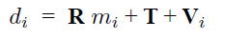
Where R is a standard 3*3 rotation matrix. T is a 3-D translation vector and Vi a noise vector. Solving for the optimal transformation [R, T] that maps the set {mi} onto {di} typically requires minimizing a least squares error criterion given by:
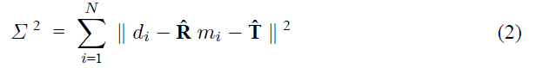
The method was developed by Arum et al. (1987) to explicitly minimize Eq.2.
In this case, a class called “ICP_3D” was created. Once the vertex coordinates from FEM is input, the transformation matrixes, R and T and the computer vision vector of the eight vertexes would be given out. The alignment first uses the singular value decomposition to get the transformation matrix R and T. Then, these transformation matrixes was applied back to get the axial vectors and the computer vision’s axial vectors.

- “Accurate” fitting with deformation
A Python class, SkeletonOfBeam, is designed to fit the accurate skeleton of the beam object. It mainly contains two parts in the process of modeling.
First step is to build the rough skeleton curve by using the skeleton vector mentioned above. Along that skeleton vector, the mesh grids of the beam object will be sliced into scores of pieces, whose centroids will be considered as the points of the skeleton curve. Then these centroid points are applied to fit the function of the rough skeleton curve by using LSE method. The error function are shown below:
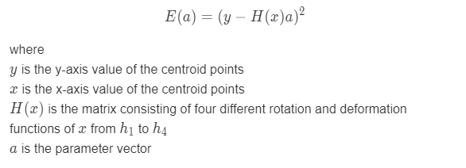
In the second step, the function of the rough skeleton curve calculated above will be utilized for more accurate fitting process. First, the rough curve will be separated uniformly into n pieces, and for each piece of beam, m points that locates in are calculated from the function of rough skeleton. After that, matrix H should be constructed. But different from the first step, since the parameter vector a in this step should serve all of the n pieces, the matrix H is specially designed to have 2*(n+1) columns, so that in the area corresponding to the ith beam, the function value from h1 to h4 will only locates in columns from number 2*i to 2*t+4, which will avoid the conflicts among different pieces of beams. Then we similarly use LSE method to get parameter a and finally derive the more accurate skeleton function.

- Cross section extraction
This part has no method. Just a very simple process of using the method implemented in the python class called trimesh.

Results/Application examples/demonstrations/validations
- CV results
After the process of the two steps of “accurate” fitting method, the results are shown below. Figure 1 displays the fitted skeleton curve in blue line and the initial skeleton points in red dot. It could be seen that no matter in XY plane or XZ plane, the projected curve of the skeleton fits the initial points accurately and also does well in eliminating noise.

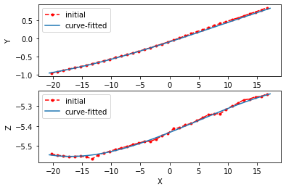
Figure 2 shown below is the side view of the actual beam object. Figure 3 is the cross sectional view. These two images both indicate that our the fitting method performs well.
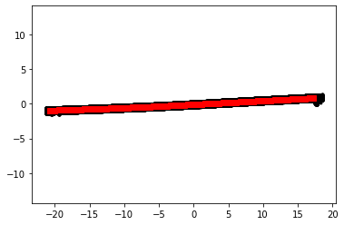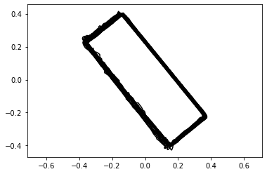

(The following content are the story of my part that written before)
In order to tackle the data of point cloud, we have written a Python class called SkeletonOfBeam. Through this class, the original data is firstly turned into a mesh model, which comprises of a great number of faces. Secondly, we apply the assumed rough skeleton vector as well as the corner points of the object beam, which are calculated in the process mentioned above, into the mesh model. After that, the roughly constructed skeleton could be found through the coding. However, because of the limitation of accuracy that comes from the assumptions, this skeleton does not satisfy our goal and therefore, in the following steps, we applied two different strategies that could be operated in sequence to develop a more accurate skeleton.

The first strategy is applying the physical law into the rough skeleton that could help to make it follow the actual rules. To be more specific, we firstly divide the rough skeleton into a certain number, called n, of smaller pieces uniformly. Then for each piece, we only consider its response of deflections and rotations of both ends. According to the physical rule, the deflection and rotation of the tail end of one beam should be equal to that of the head end of the next bean. We apply a special matrix to fulfill this phenomenon and finally got a more accurate skeleton model with multiple parameters.

The second strategy is the reconstruction of each divided beam. In strategy one, we have divided the initial skeleton into n pieces but the model we construct is still about the overall beam. Therefore in this strategy, we construct the beam model for each single piece, with which we could get different skeleton curve functions for different ranges along the skeleton.

After the application about the process mentioned above, we successfully get the skeleton model and use it to determine the geometry properties of our object beam such as the cross-sectional areas, volume and the moment inertia of the cross-section plane at any point. The results show that our strategies do help to improve the reconstruction accuracy.

